Diary No.2

Week 3: On-line

Topic: Thinking of an idea for a game of theme ‘Historical Territorial Acquisition’

Date: 09/10/2020

Team Members: Ali Noorani (myself), will Connell and Sean Colbourne.

**The Premise of The Game:**

The game was based around the war of roses (1455) and the battle of Bosworth field (1485) where two houses (York and Lancaster) fought for the reign of England.

The idea of the game originally started as a snake and ladder game board.

**The Rules and Mechanics: -**

The Rules:

* The player with the most points out of 6 wins the game.
* Only one singular player can win. In the condition of when the player get equal points (3 points each) there will be a final round between them to decide the victor.
* Losing gives the player more spending points than the winner of the round so the loser has a better chance of winning in the next confrontation.
* 2 people can play this game as a 1vs 1 or 4 people can play the game as 2 vs 2.

The Mechanics and **How the Game is Played**:

* Both players start off with the same amount of spending points to spend on troops, first aid kits and food to fight and use in the round.
* Once the players are ready to start the game, player 1 rolls a die (a singular die is used to make the round last longer and more fun to play as they have more opportunities to land on different coloured tiles).
* The number the player rolls, the player moves that many spaces.
* Depending on the tile the player lands on, whether the tile is coloured red, green, blue or white, the player gets to decide the action to either attack, defend or heal. The action is decided by the colour of the tiles labelled in Figure 1 below.
* Once first player has made a turn, the second player does the same. The action the second player can do or has to do is also decided by the tiles.
* At the end of the round, the winner is decided by who has won the most face offs, as within one round there are many battles taking place just like the war of roses which consisted of many tiny battles.
* The winner is also awarded a certain amount of points to use in the next round.
* The loser of the round is also awarded points; however, the amount of points is higher than the winner is awarded. This is to allow the loser to come back as the victor in the next round and keep things interesting and fun for both the players. This mechanic also comes in as an element of surprise for both players.
* This is then repeated 6 times in total, and the player with the most points is the winner.
* 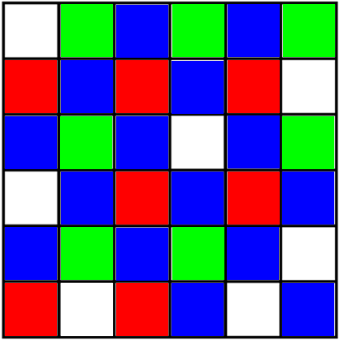In the outcome of a draw, meaning both players having 3 points each, a final 7th round is held to decide the victor.

B

D

C

F

A

E

Figure 1 (A) Start of Round (B) White Tile, Heal/ Hire Troops (C) Red Tile, Attack (D) Blue Tile,

Attack/ Defend (E) Green Tile, Defend (F) End of Round

**Materials Used to Make the Game:**

* 1 6x6 board, the same size as a snakes and ladder board.
* 2 small pieces to represent the different teams
* Cards to use during the attack/ defend/ heal/ hire phase of the game.

**Play Testing Findings:**

The team found a few problems with the game when play testing such as, the use of cards, points and tiles in the early stages of development. How they were going to make the game fun, challenging, interesting and surprising to play.

After play testing and fixing the problems that came up, the game looked ready to be presented.

**My Personal Experience in Working with Teams:**

Last week, the team I worked with synergised nicely in that we were able to agree with each other and bounce off ideas for the game better than this week.

This week, the team I was in, was agreeing, however were in the process of one upping the other member. Although this sparked a great idea for a game, it took most of the time to just think of the idea. The mechanics and rules had not been made in the first half an hour nor had they begun.

The good thing about the team was that everyone was creative and had great ideas for games. It took longer to agree to a single game idea.

Once the game idea was decided, everyone in the team had a task in mind that they wanted to do once the game was designed. So everyone went out on their own to do the tasks in mind and combine them at the end. As the tasks were combined in the end, the team did not have enough time to review every single information, and so, some discrepancies were left in the presentation, from what was written on the slides and what was said at the time by the team.

In the future, I want to be able to time manage the different tasks of thinking of a game idea into smaller sections, so everything is not out of place and everyone is not going off on their own, doing their own thing. One task done together takes less time than doing all the tasks together and merging them up at the end.